**FUZZING**

Fuzzing or fuzz testing is an automated software testing technique that involves providing invalid, unexpected, or random data as inputs to a computer program.

**Implementation in the todoList CI/CD pipeline:**

Tool chosen: **JavaFuzz** -> <https://github.com/fuzzitdev/javafuzz>

* Add the dependency in your maven pom.xml (not done as modifying the project’s application is not one of our goals)
* Implement the following function (not done as modifying the project’s application is not one of our goals):

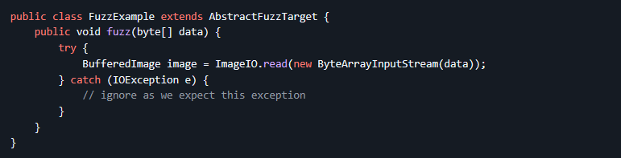

* Install java fuzzing: wget -O jacocoagent.jar <https://github.com/fuzzitdev/javafuzz/raw/master/javafuzz-maven-plugin/src/main/resources/jacocoagent-exp.jar>
* Run the fuzzing: MAVEN_OPTS="-javaagent:jacocoagent.jar" mvn javafuzz:fuzz -DclassName=fuzzing.class.test.path

We make the implementation required as said in the previous segment, adding the following class, to the testing packages:

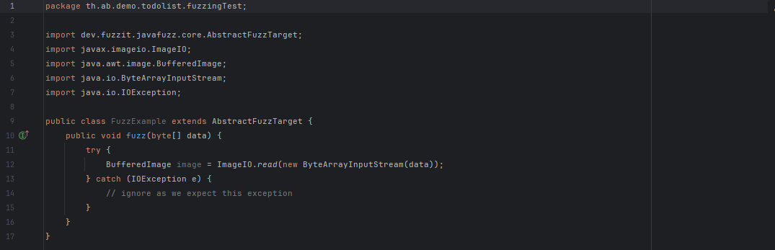

As it can be seen the fuzzing function made is just an example to check that it can indeed be called, therefore it does not require any further explanation.

After that, It has also been needed to install in the Docker Image the jacoco plugin for maven to run the command properly.

After running the command in the pipeline, the next outcome is showed:

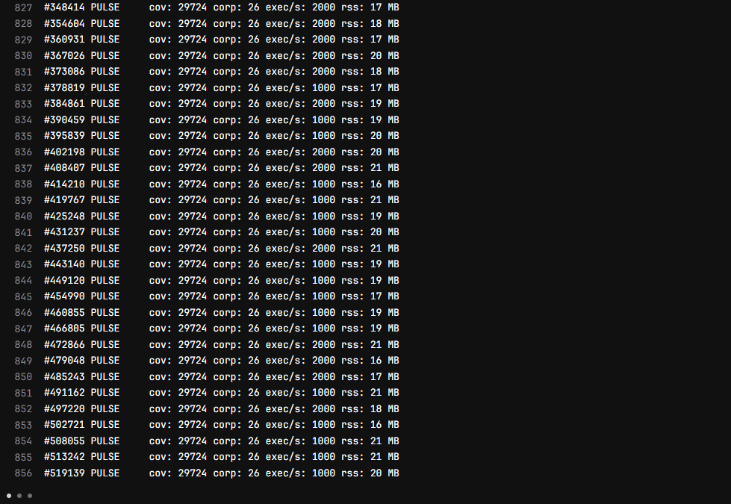

Showing that it is indeed working.